**- Do exploration testing for the basic functions of Wikipedia app.**

**Bugs**

**Bug id:** S.B-000001

**Title:** When user tries to open any article, user is navigated to error page

**Priority:** P1

**Device:** Samsung S10+

**Reproduction steps:**

1. Open the application
2. Tap on any article

**Actual Result:**

User is navigated to error page

**Expected Result:**

Article should open without any error

**Screenshot:**

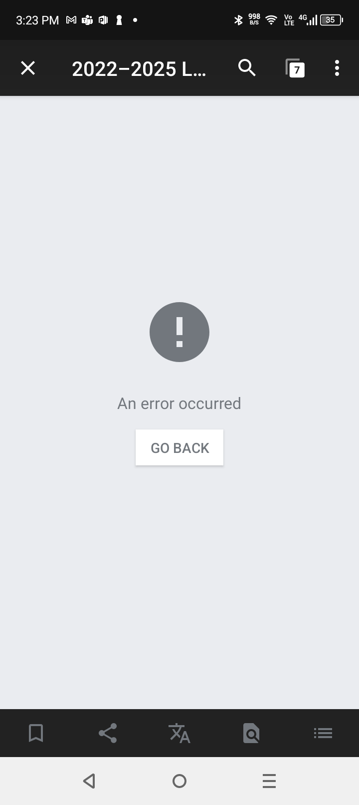

**Bug id:** S.B-000002

**Title:** Changed language is not updated automatically unless user refreshes the Explore screen

**Device:** Samsung S10+

**Priority:** P2

**Reproduction steps:**

1. Open the application
2. Tap three dot menu on top right
3. Tap settings
4. Change Wikipedia language to any other language
5. Tab back button from top left

**Actual Result:**

Language update is not reflected on the Explorer screen. [It work fines after user refreshes the Explorer screen]

**Expected Result:**

Language change should be reflected on Explorer screen right after the language is updated

**Screenshot:**

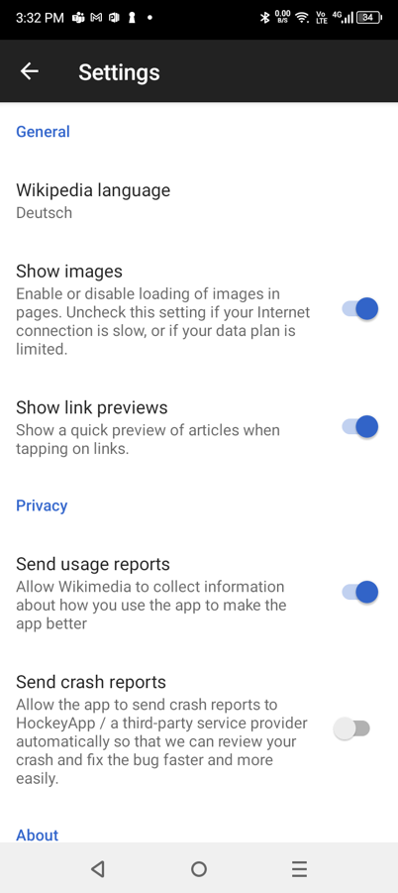

**Bug id:** S.B-000003

**Title:** Nearby screen does not show the map and gives an error message

**Device:** Samsung S10+

**Priority:** P2

**Reproduction steps:**

1. Open the application
2. Tap on Nearby button from bottom right

**Actual Result:**

Maps do not load and show an error message

**Expected Result:**

Maps should load without any errors

**Screenshot:**

**Bug id:** S.B-000004

**Title:** Enter wrong user name and password after changing language to German shows different error message with Captcha related info

**Device:** Samsung S10+

**Browser:** Chrome

**Priority:** P3

**Reproduction steps:**

1. Open the application
2. Change Language to German from Settings
3. Tap on any Log in to Wikipedia from the three dot menu on top right
4. Provide invalid user name and password
5. See the error message

**Actual Result:**

Error message contains text including Captcha related details

**Expected Result:**

Error message should remain same with different languages – just the language should change

**Screenshot:**

**Bug id:** S.B-000005

**Title:** User should remain on registration screen if wrong captcha is provided

**Device:** Samsung S10+

**Browser:** Chrome

**Priority:** P2

**Reproduction steps:**

1. Open the application
2. Tap on any Log in to Wikipedia from the three dot menu on top right
3. Tap Don’t have an account? Link
4. Provide required details
5. Tap Next button
6. Provide invalid captcha value
7. Tap Create account button
8. Tap on back button from top left

**Actual Result:**

User is navigated to Login screen

**Expected Result:**

User should navigate to the Registration screen

**Bug id:** S.B-000006

**Title:** Repeat password field disappears when user clicks the show password button

**Device:** Samsung S10+

**Browser:** Chrome

**Priority:** P2

**Reproduction steps:**

1. Open the application
2. Tap on any Log in to Wikipedia from the three dot menu on top right
3. Tap Don’t have an account? Link
4. Provide User Name and Password
5. Tab on Repeat password screen
6. Tap on Show Password Eye icon

**Actual Result:**

Repeat password field disappears

**Expected Result:**

Repeat password field should not disappear

**Screenshot:**

**Bug id:** S.B-000007

**Title:** On wrong captcha user gets a message that the user is already registered

**Device:** Samsung S10+

**Browser:** Chrome

**Priority:** P3

**Reproduction steps:**

1. Open the application
2. Tap on any Log in to Wikipedia from the three dot menu on top right
3. Tap Don’t have an account? Link
4. Provide required details
5. Tap Next button
6. Provide invalid captcha value

**Actual Result:**

User gets a message that the user is already registered

**Expected Result:**

User should see a message stating wrong captcha code

**Screenshot:**

**Bug id:** S.B-000008

**Title:** On language change different articles are shown

**Device:** Samsung S10+

**Browser:** Chrome

**Priority:** P2

**Reproduction steps:**

1. Open the application
2. Note the articles which are visible
3. Tap three dot menu on top right
4. Tap settings
5. Change Wikipedia language to any other language
6. Tab back button from top left
7. Observe the articles are different as compared to step 2

**Actual Result:**

Different articles are visible after language change

**Expected Result:**

User should see same articles with updated language

**Screenshot:**

